Step 1 – Installing Python:

Navigate to this link and Python executable will download automatically:

<https://www.python.org/ftp/python/3.8.0/python-3.8.0-amd64.exe>

Step 2 – The installation:

1. Make sure you check mark both the options and click on INSTALL NOW

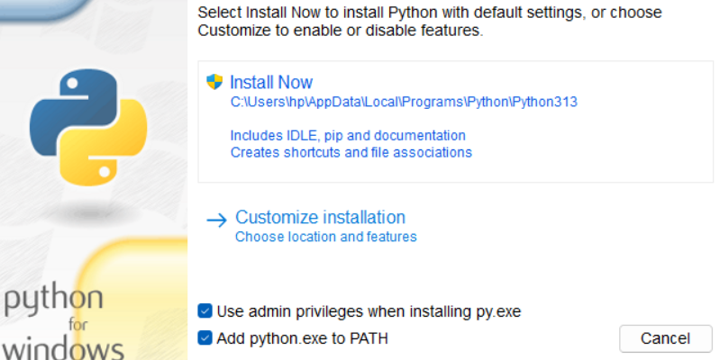

1. Let the setup install and once finished close the setup.

Step 3 – Now head over to the project directory:

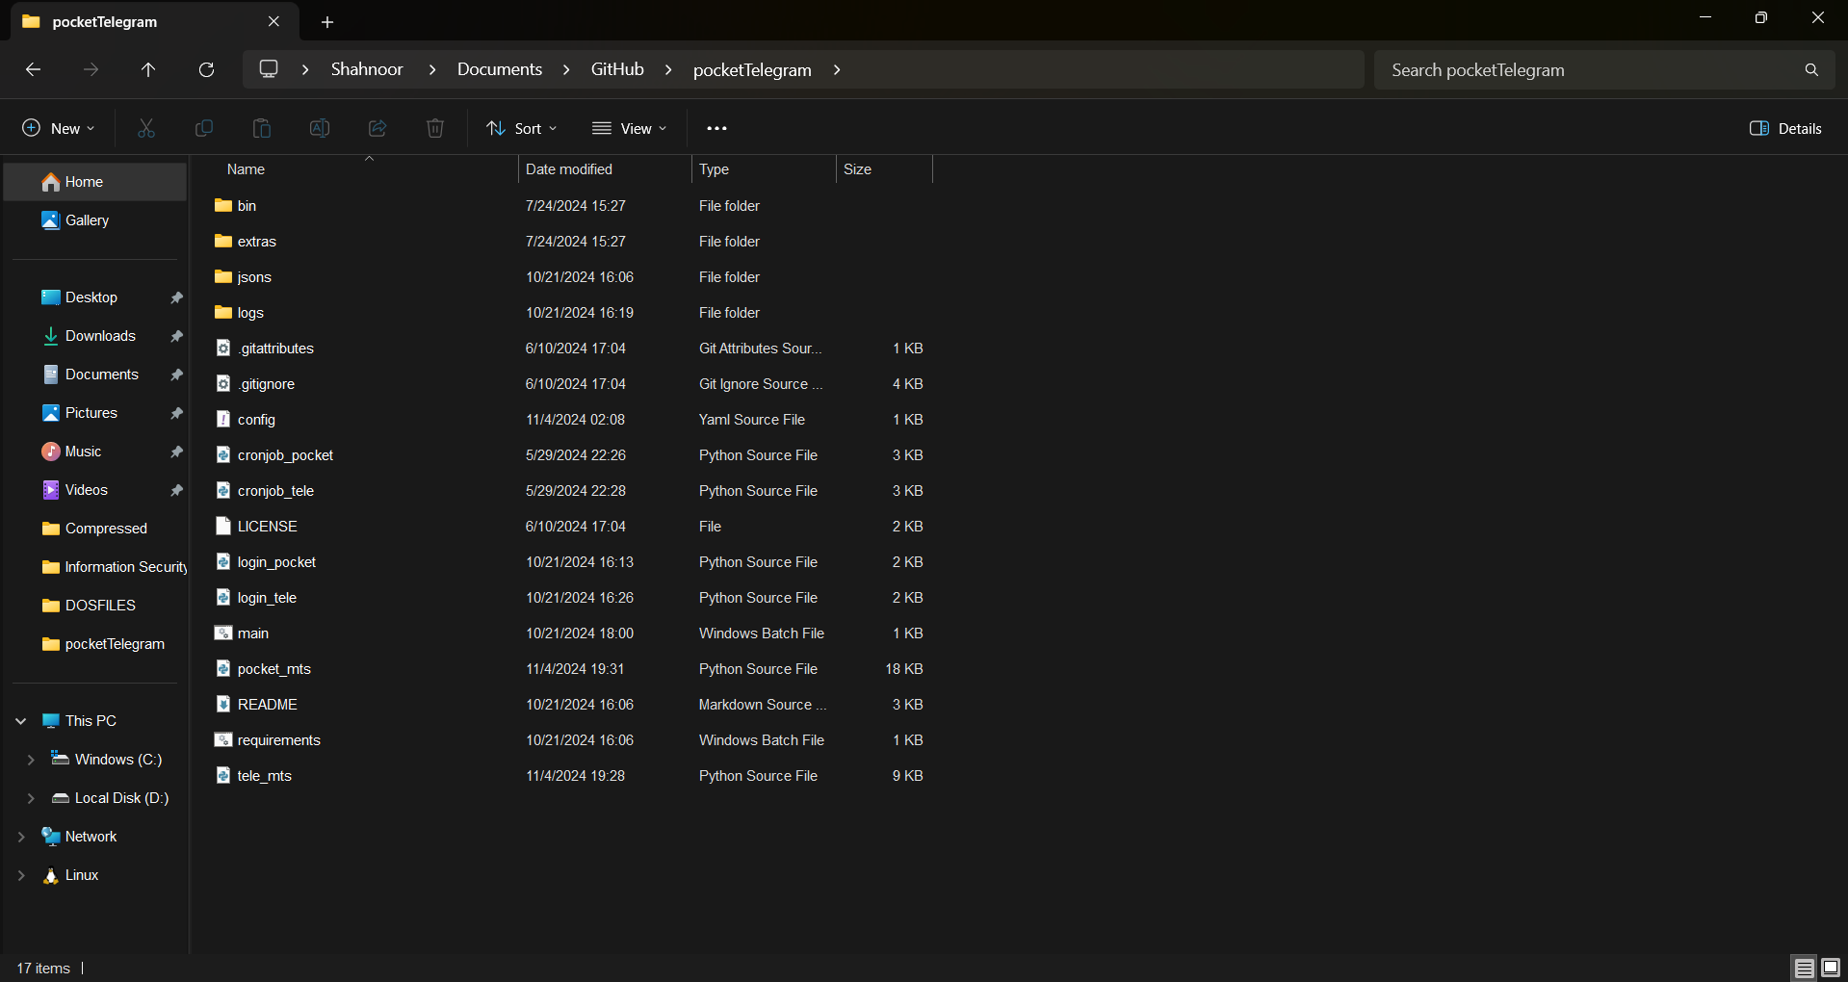

1. Double click on requirements.bat file once opened a terminal will pop up like this:

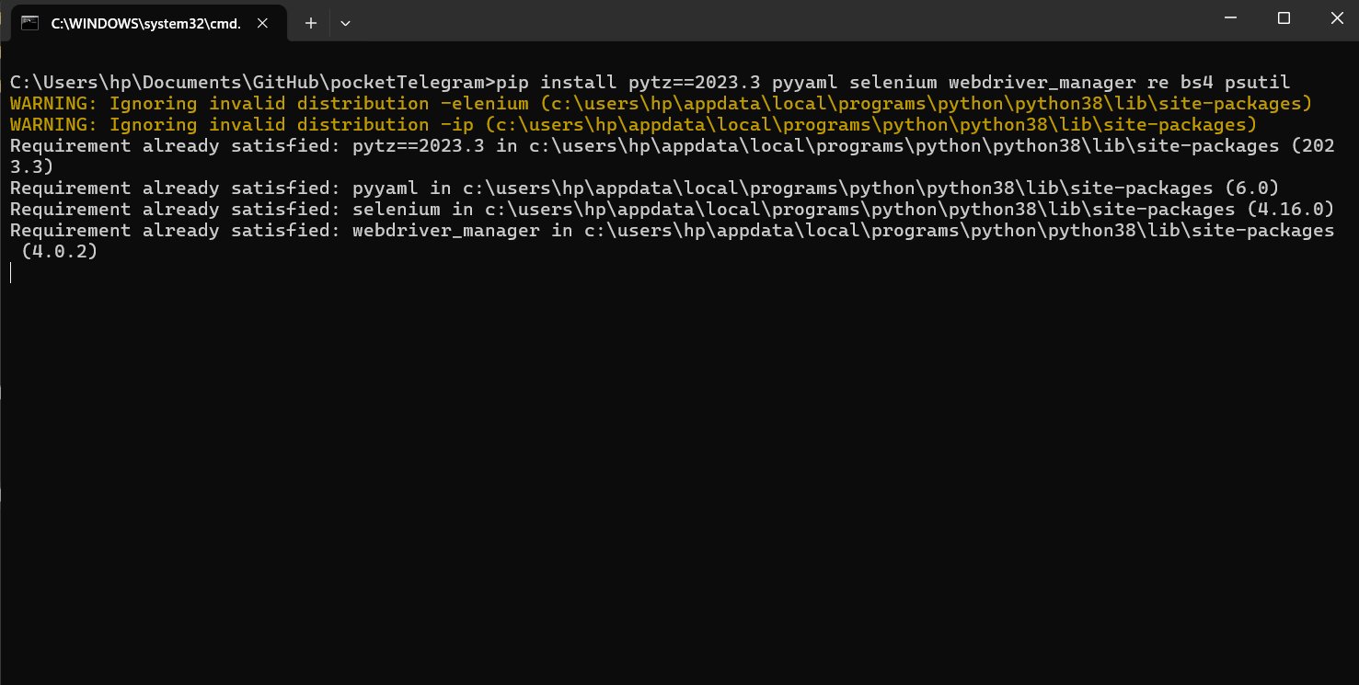

1. Let the process complete and once completed it should close itself, if it stops somewhere and you see some RED lines, contact me there might be some unexpected issue.

At this point the installation of Python and its dependencies is complete.

Step 4 – Logging into Telegram Web:

1. Head over to the project directory and open up a COMMAND PROMPT terminal or POWERSHELL terminal.
2. Make sure you have Chrome installed and you are using the latest version, you can check whether there is an update for chrome or not, you can check the latest update in the Chrome settings in the about section.
3. Now come back to the terminal and type “python login_tele.py” and press ENTER.
4. You will see a chrome tab opening and navigating to (<https://web.telegram.org/>), you would have to login using you’re Telegram App.
5. Once you have logged in, close the Chrome instance, at this point your login session will be saved on your computer.

Step 5 – Logging into Pocket Option:

1. It’s similar to logging in to Telegram web, open up a terminal in the project directory and once opened, type in “python login_pocket.py” in the terminal and press ENTER.
2. A Chrome instance would open up and will navigate you to (<https://www.pocketoption.com/en/login>)
3. Once the page has loaded login to your Pocket Option account, and once you have logged in and are on the main page close the window, at this point your login session will be saved on your computer.

Step 6 – Running the bot:

I have already configured the bot to run on the two sessions (morning and evening) you don’t have to run the files separately on your own.

To run the bots just double click on the “main.bat” in the project directory and the bots will start running.

P.S: Try avoiding to use the computer once the bots are running, but if you do have to do some urgent work on the computer while the bots are running, please MINIMIZE the Chrome windows.

- Do not click in the bot opened chrome instances if you do that would interrupt the process, and you might have to face unexpected behavior of the bots.